PRODUCTION PLANNING AND CONTROL
PPC

Introduction

Production Planning is a managerial function which is mainly concerned with the following important issues:

- What production facilities are required?

- How these production facilities should be laid down in the space available for production? and

- How they should be used to produce the desired products at the desired rate of production?

Broadly speaking, production planning is concerned with two main aspects: (i) routing or planning work tasks (ii) layout or spatial relationship between the resources. Production planning is dynamic in nature and always remains in fluid state as plans may have to be changed according to the changes in circumstances.

Production control is a mechanism to monitor the execution of the plans. It has several important functions:

- Making sure that production operations are started at planned places and planned times.
- Observing progress of the operations and recording it properly.

- Analyzing the recorded data with the plans and measuring the deviations.

- Taking immediate corrective actions to minimize the negative impact of deviations from the plans.

- Feeding back the recorded information to the planning section in order to improve future plans.

A block diagram depicting the architecture of a control system is shown in Figure1.

Figure 1: Architecture of Control System
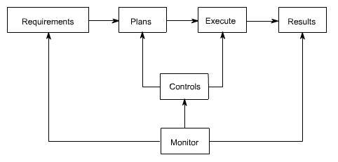

Important functions covered by production planning and control (PPC) function in any manufacturing system are shown in Table1along with the issues to be covered.

2
Table 1: Production Planning and control Functions

Functions |  | Issues to be covered

Product

Design& Developme nt

Demand Forecasting

Capacity Planning

Equipment
- Selection

&

Maintenan ce

Customer needs, market needs, availability of similar product, demand-supply gap, functional aspects, operational aspects, environmental aspects etc.

Quantity, Quality, Demand

pattern.

No. of machines, No. of tooling, workers, No.of flow lines, Quantity, Quality and rate of production, demand pattern.

No. of machines, type of M/c, Quality aspects, Quantity aspects, rate of production, Cost of equipments, support from the supplier, maintenance policy, storage of spare parts.

Tooling |  | Compactability between w/c steels, No. of tools, their cost, their material etc, storage
Selection |  | policy.
Material
Selection |  | Types, specification, quality aspect, quantity aspect, cost, supplies reputation , lot size,
&
& |  | inventory levels, setup cost, mode of transportation etc.
Manageme |  | inventory levels, setup cost, mode of transportation etc.
nt
Process |  | Generation of manufacture instruction, selection of M/c, tools, parameters, sequence
Planning |  | etc.
Loading |  | Division of work load, assignment of tasks, uniform loading, matching between
Loading |  | capability & capacity with job requirements.
Routing |  | Path selection for material movement as per the process plan and loading, minimum
Routing |  | material handling and waiting time.
Scheduling |  | Time based loading, start and finish times, due dates, dispatching rules, re-scheduling.
Expediting |  | Operation Scheduling and order and progress reporting.

Types of Production Systems

A production system can be defined as a transformation system in which a saleable product or service is created by working upon a set of inputs. Inputs are usually in the form of men, machine, money, materials etc. Production systems are usually classified on the basis of the following:

- Type of product,
- Type of production line,

- Rate of production,
- Equipments used etc.

3

They are broadly classified into three categories:

- Job shop production
- Batch production

- Mass production

Job Production

In this system products are made to satisfy a specific order. However that order may be produced-

- only once

- or at irregular time intervals as and when new order arrives
- or at regular time intervals to satisfy a continuous demand

The following are the important characteristics of job shop type production system:

- Machines and methods employed should be general purpose as product changes are quite frequent.

- Planning and control system should be flexible enough to deal with the frequent changes in product requirements.

- Man power should be skilled enough to deal with changing work conditions.

- Schedules are actually non existent in this system as no definite data is available on the product.

- In process inventory will usually be high as accurate plans and schedules do not exist.

- Product cost is normally high because of high material and labor costs.
- Grouping of machines is done on functional basis (i.e. as lathe section, milling section etc.)

- This system is very flexible as management has to manufacture varying product types.
- Material handling systems are also flexible to meet changing product requirements.

Batch Production

Batch production is the manufacture of a number of identical articles either to meet a specific order or to meet a continuous demand. Batch can be manufactured either-

- only once

- or repeatedly at irregular time intervals as and when demand arise
- or repeatedly at regular time intervals to satisfy a continuous demand

The following are the important characteristics of batch type production system:

- As final product is somewhat standard and manufactured in batches, economy of scale can be availed to some extent.

- Machines are grouped on functional basis similar to the job shop manufacturing.

- Semi automatic, special purpose automatic machines are generally used to take advantage of the similarity among the products.

- Labor should be skilled enough to work upon different product batches.

- In process inventory is usually high owing to the type of layout and material handling policies adopted.

- Semi automatic material handling systems are most appropriate in conjunction with the semi automatic machines.

4
- Normally production planning and control is difficult due to the odd size and non repetitive nature of order.

Mass Production

In mass production, same type of product is manufactured to meet the continuous demand of the product. Usually demand of the product is very high and market is going to sustain same demand for sufficiently long time.

The following are the important characteristics of mass production system:

- As same product is manufactured for sufficiently long time, machines can be laid down in order of processing sequence. Product type layout is most appropriate for mass production system.

- Standard methods and machines are used during part manufacture.

- Most of the equipments are semi automatic or automatic in nature.
- Material handling is also automatic (such as conveyors).

- Semi skilled workers are normally employed as most of the facilities are automatic.
- As product flows along a pre defined line, planning and control of the system is much easier.

- Cost of production is low owing to the high rate of production.

- In process inventories are low as production scheduling is simple and can be implemented with ease.

PRODUCT DESIGN

- Product design is a strategic decision as the image and profit earning capacity of a small firm depends largely on product design. Once the product to be produced is decided by the entrepreneur the next step is to prepare its design. Product design consists of form and function. The form designing includes decisions regarding its shape, size, color and appearance of the product. The functional design involves the working conditions of the product. Once a product is designed, it prevails for a long time therefore various factors are to be considered before designing it. These

factors are listed below: -

- (a) Standardization
- (b) Reliability

- (c) Maintainability
- (d) Servicing

- (e) Reproducibility
- (f) Sustainability

- (g) Product simplification
- (h) Quality Commensuration with cost

- (i) Product value
- (j) Consumer quality

- (k) Needs and tastes of consumers.

5
Above all, the product design should be dictated by the market demand. It is an important decision and therefore the entrepreneur should pay due effort, time,energy and attention in order to get the best results.

TYPES OF PRODUCTION SYSTEM

Broadly one can think of three types of production systems which are mentioned here under: -

  - Continuous production
  - Job or unit production

  - Intermittent production

- Continuous production: - It refers to the production of standardized products with a standard set of process and operation sequence in anticipation of demand. It is also known as mass flow production or assembly line productionThis system ensures less work in process inventory and high product quality butinvolves large investment in machinery and equipment. The system is suitable in 117plants involving large volume and small variety of output e.g. oil refineries reform cement manufacturing etc.

- Job or Unit production: - It involves production as per customer's specification each batch or order consists of a small lot of identical products andis different from other batches. The system requires comparatively smallerinvestment in machines and equipment. It is flexible and can be adapted tochanges in product design and order size without much inconvenience. This system is most suitable where heterogeneous products are produced againstspecific orders.

- Intermittent Production: Under this system the goods are produced partly for inventory and partly for customer's orders. E.g. components are made forinventory but they are combined differently for different customers. . Automobileplants, printing presses, electrical goods plant are examples of this type ofmanufacturing.

FORE CASTING

Introduction

The growing competition, frequent changes in customer's demand and the trend towards automation demand that decisions in business should not be based purely on guesses rather on a careful analysis of data concerning the future course of events. More time and attention should be given to the future than to the past, and the question 'what is likely to happen?' should take precedence over 'what has happened?' though no attempt to answer the first can be made without the facts and figures being available to answer the second. When estimates of future conditions are made on a systematic basis, the process is called forecasting and the figure or statement thus obtained is defined as forecast.

In a world where future is not known with certainty, virtually every business and economic decision rests upon a forecast of future conditions. Forecasting aims at reducing the area of uncertainty that surrounds management decision-making with respect to costs, profit, sales, production, pricing, capital investment, and so forth. If the future were known with certainty, forecasting would be unnecessary. But uncertainty does exist, future outcomes are rarely assured and, therefore, organized system of forecasting is necessary. The following are the main functions of forecasting:

6
- The creation of plans of action.

- The general use of forecasting is to be found in monitoring the continuing progress of plans based on forecasts.

- The forecast provides a warning system of the critical factors to be monitored regularly because they might drastically affect the performance of the plan.

It is important to note that the objective of business forecasting is not to determine a curve or series of figures that will tell exactly what will happen, say, a year in advance, but it is to make analysis based on definite statistical data, which will enable an executive to take advantage of future conditions to a greater extent than he could do without them. In forecasting one should note that it is impossible to forecast the future precisely and there always must be some range of error allowed for in the forecast.

FORECASTING FUNDAMENTALS

Forecast: A prediction, projection, or estimate of some future activity, event, or occurrence.

Types of Forecasts

- Economic forecasts

  - Predict a variety of economic indicators, like money supply, inflation rates, interest rates, etc.

- Technological forecasts
  - Predict rates of technological progress and innovation.

- Demand forecasts
  - Predict the future demand for a company’s products or services.

Since virtually all the operations management decisions (in both the strategic category and the tactical category) require as input a good estimate of future demand, this is the type of forecasting that is emphasized in our textbook and in this course.

TYPES OF FORECASTING METHODS

Qualitative methods: These types of forecasting methods are based on judgments, opinions, intuition, emotions, or personal experiences and are subjective in nature. They do not rely on any rigorous mathematical computations

Quantitative methods: These types of forecasting methods are based on mathematical (quantitative) models, and are objective in nature. They rely heavily on mathematical computations.

QUALITATIVE FORECASTING METHODS

Qualitative Methods

7
Executive |  | Market |  | Sales Force |  | Delphi
Opinion |  | Survey |  | Composite |  | Method
Approach in which |  | Approach that |  | Approach in which |  | Approach in which
Approach in which |  | Approach that |  | each salesperson |  | Approach in which
a group of |  | uses interviews |  | each salesperson |  | consensus
a group of |  | uses interviews |  | estimates sales in |  | consensus
managers meet |  | and surveys to |  | estimates sales in |  | agreement is
managers meet |  | and surveys to |  | his or her region |  | agreement is

8
QUANTITATIVE FORECASTING METHODS

Quantitative Methods
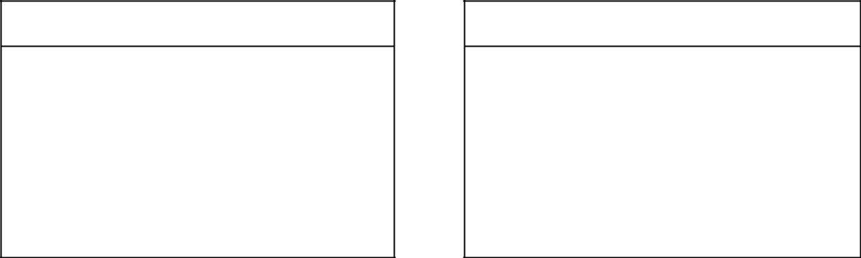

Time-Series Models

Time series models look at past patterns of data and attempt to predict the future based upon the underlying patterns contained within those data.

Associative Models

Associative models (often called causal models) assume that the variable being forecasted is related to other variables in the environment. They try to project based upon those

 | TIME SERIES MODELS
Model |  | Description
Naïve |  | Uses last period’s actual value as a forecast
Simple Mean (Average) |  | Uses an average of all past data as a forecast
Simple Moving Average |  | Uses an average of a specified number of the most
Simple Moving Average |  | recent observations, with each observation receiving the
 |  | same emphasis (weight)
Weighted Moving Average |  | Uses an average of a specified number of the most
Weighted Moving Average |  | recent observations, with each observation receiving a
 |  | different emphasis (weight)
Exponential Smoothing |  | A weighted average procedure with weights declining
Exponential Smoothing |  | exponentially as data become older

9

Technique that uses the least squares method to fit a
Trend Projection
straight line to the data

A mechanism for adjusting the forecast to accommodate
Seasonal Indexes
any seasonal patterns inherent in the data

10
DECOMPOSITION OF A TIME SERIES

Patterns that may be present in a time series

Trend: Data exhibit a steady growth or decline over time.

Seasonality: Data exhibit upward and downward swings in a short to intermediate time frame (most notably during a year).

Cycles: Data exhibit upward and downward swings in over a very long time frame.

Random variations: Erratic and unpredictable variation in the data over time with no discernable pattern.

ILLUSTRATION OF TIME SERIES DECOMPOSITION

Hypothetical Pattern of Historical Demand

Dependent versus Independent Demand

Demand of an item is termed as independent when it remains unaffected by the demand for any other item. On the other hand, when the demand of one item is linked to the demand for another item, demand is termed as dependent. It is important to mention that only independent demand needs forecasting. Dependent demand can be derived from the demand of independent item to which it is linked.

Business Time Series

The first step in making a forecast consists of gathering information from the past. One should collect statistical data recorded at successive intervals of time. Such a data is usually referred to as time series. Analysts plot demand data on a time scale, study the plot and look for consistent shapes and patterns. A time series of demand may have constant, trend, or seasonal pattern ( Figure 1 )

Figure 1: Business Time Series

11
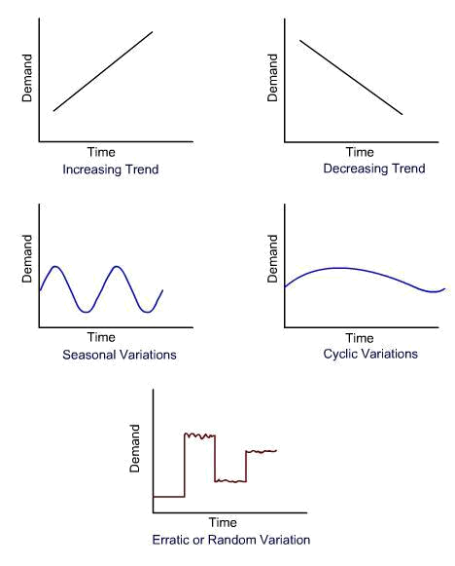

or some combination of these patterns. The forecaster tries to understand the reasons for such changes, such as,

- Changes that have occurred as a result of general tendency of the data to increase or decrease, known as secular movements.

- Changes that have taken place during a period of 12 months as a result in changes in climate, weather conditions, festivals etc. are called as seasonal changes.

- Changes that have taken place as a result of booms and depressions are called as cyclical variations.

- Changes that have taken place as a result of such forces that could not be predicted (like flood, earthquake etc.) are called as irregular or erratic variations.

Quantitative Approaches of Forecasting

Most of the quantitative techniques calculate demand forecast as an average from the past demand.
The following are the important demand forecasting techniques.

- Simple average method: A simple average of demands occurring in all previous time periods is taken as the demand forecast for the next time period in this method. ( Example 1 )

Example 1

Simple Average :

A XYZ television supplier found a demand of 200 sets in July, 225 sets in August & 245 sets in September. Find the demand forecast for the month of october using simple average method.
The average demand for the month of October is

12
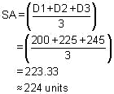

- Simple moving average method: In this method, the average of the demands from several of the most recent periods is taken as the demand forecast for the next time period. The number of past periods to be used in calculations is selected in the beginning and is kept constant (such as 3-period moving average). (Example 2 )

Simple Moving Average :

A XYZ refrigerator supplier has experienced the following demand for refrigerator during past five months.
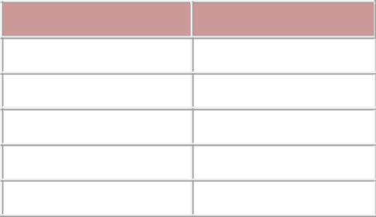

Month Demand

February 20

March 30

April 40

May 60

June 45

Find out the demand forecast for the month of July using five-period moving average & three-period moving average using simple moving average method.
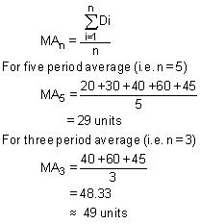

- Weighted moving average method: In this method, unequal weights are assigned to the past demand data while calculating simple moving average as the demand forecast for next time period. Usually most recent data is assigned the highest weight factor. (Example 3 )

Example 3

Weighted Moving Average Method :

The manager of a restaurant wants to make decision on inventory and overall cost. He wants to forecast demand for some of the items based on weighted moving average method. For the past three months he exprienced a demand for pizzas as follows:

13
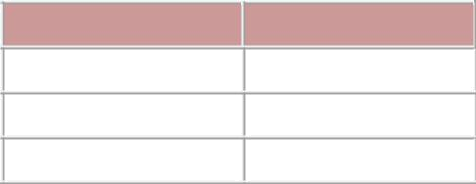
Month Demand

October 400

November 480

December 550

Find the demand for the month of January by assuming suitable weights to demand data.
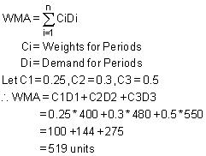

- Exponential smoothing method: In this method, weights are assigned in exponential order. The weights decrease exponentially from most recent demand data to older demand data. (Example 4 )

Example 4
Exponential Smoothing :

One of the two wheeler manufacturing company exprienced irregular but usually increasing demand for three products. The demand was found to be 420 bikes for June and 440 bikes for July. They use a forecasting method which takes average of past year to forecast future demand. Using the simple average method demand forecast for June is found as 320 bikes (Use a smoothing coefficient 0.7 to weight the recent demand most heavily) and find the demand forecast for August.
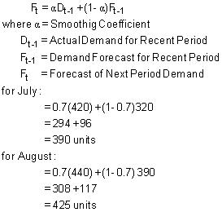

- Regression analysis method: In this method, past demand data is used to establish a functional relationship between two variables. One variable is known or assumed to be known; and used to forecast the value of other unknown variable (i.e. demand). (Example 5 )

Example 5

14
Regression Analysis :

Farewell Corporation manufactures Integrated Circuit boards(I.C board) for electronics devices. The planning department knows that the sales of their client goods depends on how much they spend on advertising, on account of which they receive in advance of expenditure. The planning department wish to find out the relationship between their clients advertising and sales, so as to find demand for I.C board.

The money spend by the client on advertising and sales (in dollar) is given for different periods in following table :

 | Advertising | Sales (Dt)
Period(t) | (Xt) | Sales (Dt) | Dt² | Xt² | XtDt
 | $(1,00,000) | $(1,000.000)
1 | 20 | 6 | 36 | 400 | 120
2 | 25 | 8 | 64 | 625 | 200
3 | 15 | 7 | 49 | 225 | 105
4 | 18 | 7 | 49 | 324 | 126
5 | 22 | 8 | 64 | 484 | 176
6 | 25 | 9 | 81 | 625 | 225
7 | 27 | 10 | 100 | 729 | 270
8 | 23 | 7 | 49 | 529 | 161
9 | 16 | 6 | 36 | 256 | 96
10 | 20 | 8 | 64 | 400 | 120
 | 211 | 76 | 592 | 4597 | 1599
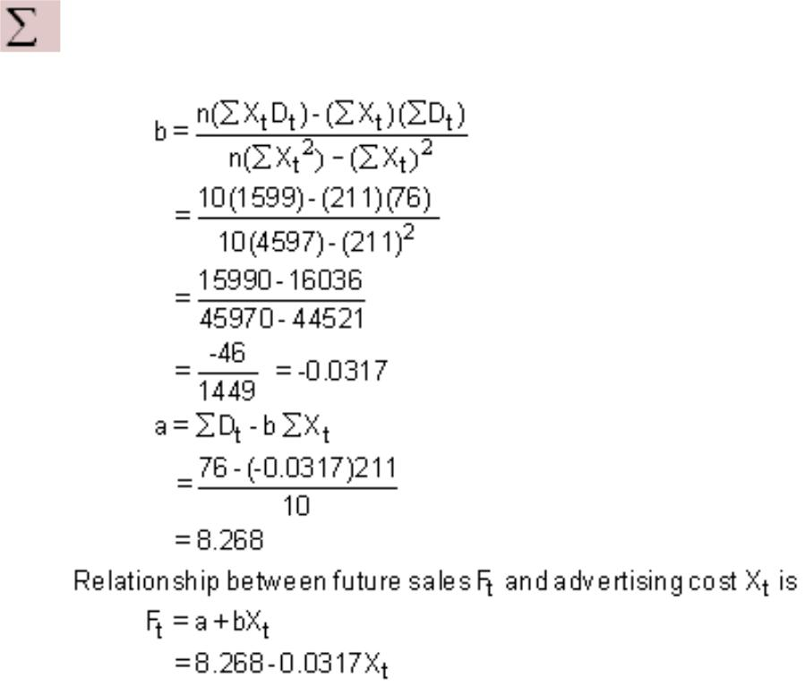

Error in Forecasting

Error in forecasting is nothing but the numeric difference in the forecasted demand and actual demand. MAD (Mean Absolute Deviation) and Bias are two measures that are used to assess the accuracy of the forecasted demand. It may be noted that MAD expresses the magnitude but not the direction of the error.

15
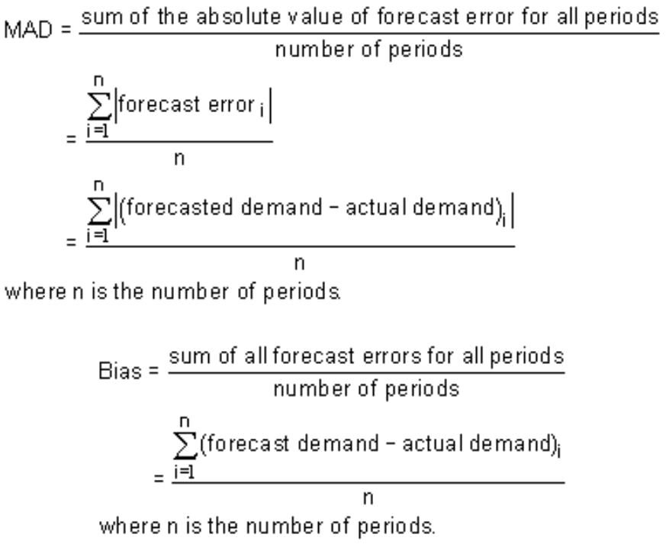

16
INVENTORY

Introduction

The amount of material, a company has in stock at a specific time is known as inventory or in terms of money it can be defined as the total capital investment over all the materials stocked in the company at any specific time. Inventory may be in the form of,

- raw material inventory

- in process inventory
- finished goods inventory

- spare parts inventory
- office stationary etc.

As a lot of money is engaged in the inventories along with their high carrying costs, companies cannot afford to have any money tied in excess inventories. Any excessive investment in inventories may prove to be a serious drag on the successful working of an organization. Thus there is a need to manage our inventories more effectively to free the excessive amount of capital engaged in the materials.

Why Inventories?

Inventories are needed because demand and supply can not be matched for physical and economical reasons. There are several other reasons for carrying inventories in any organization.

- To safe guard against the uncertainties in price fluctuations, supply conditions, demand conditions, lead times, transport contingencies etc.

- To reduce machine idle times by providing enough in-process inventories at appropriate locations.

- To take advantages of quantity discounts, economy of scale in transportation etc.

- To decouple operations i.e. to make one operation's supply independent of another's supply. This helps in minimizing the impact of break downs, shortages etc. on the performance of the downstream operations. Moreover operations can be scheduled independent of each other if operations are decoupled.

- To reduce the material handling cost of semi-finished products by moving them in large quantities between operations.

- To reduce clerical cost associated with order preparation, order procurement etc.

Inventory Costs

In order to control inventories appropriately, one has to consider all cost elements that are associated with the inventories. There are four such cost elements, which do affect cost of inventory.

- Unit cost: it is usually the purchase price of the item under consideration. If unit cost is related with the purchase quantity, it is called as discount price.

- Procurement costs: This includes the cost of order preparation, tender placement, cost of postages, telephone costs, receiving costs, set up cost etc.

17
- Carrying costs: This represents the cost of maintaining inventories in the plant. It includes the cost of insurance, security, warehouse rent, taxes, interest on capital engaged, spoilage, breakage etc.

- Stockout costs: This represents the cost of loss of demand due to shortage in supplies. This includes cost of loss of profit, loss of customer, loss of goodwill, penalty etc.

If one year planning horizon is used, the total annual cost of inventory can be expressed as:

Total annual inventory cost = Cost of items + Annual procurement cost + Annual carrying cost + Stockout cost

Variables in Inventory Models

D = Total annual demand (in units)

Q = Quantity ordered (in units)

Q* = Optimal order quantity (in units)

R = Reorder point (in units)

R* = Optimal reorder point (in units)

L = Lead time

S = Procurement cost (per order)

C = Cost of the individual item (cost per unit)

I = Carrying cost per unit carried (as a percentage of unit cost C)

K = Stockout cost per unit out of stock

P = Production rate or delivery rate

dl = Demand per unit time during lead time

Dl = Total demand during lead time

TC = Total annual inventory costs

TC* = Minimum total annual inventory costs

Number of orders per year = 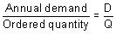

Total procurement cost per year = S.D / Q

Total carrying cost per year = Carrying cost per unit * unit cost * average inventory per cycle

18
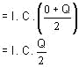

Cost of items per year = Annual demand * unit cost

= D.C

Total annual inventory cost (TC) = 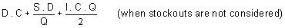

The objective of inventory management team is to minimize the total annual inventory cost. A simplified graphical presentation in which cost of items, procurement cost and carrying cost are depicted is shown in Figure 1 . It can be seen that large values of order quantity Q result in large carrying cost. Similarly, when order quantity Q is large, fewer orders will be placed and procurement cost will decrease accordingly. The total cost curve indicates that the minimum cost point lies at the intersection of carrying cost and procurement cost curves.

Figure 1 : Inventory Related Costs
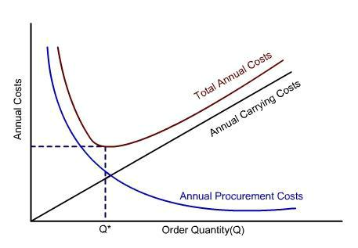

Inventory Operating Doctrine

When managing inventories, operations manager has to make two important decisions:

- When to reorder the stock (i.e. time to reorder or reorder point)
- How much stock to reorder (i.e. order quantity)

19
Reorder point is usually a predetermined inventory level, which signals the operations manager to start the procurement process for the next order. Order quantity is the order size.

Inventory Modelling

This is a quantitative approach for deriving the minimum cost model for the inventory problem in hand.

Economic Order Quantity (EOQ) Model

This model is applied when objective is to minimize the total annual cost of inventory in the organization. Economic order quantity is that size of the order which helps in attaining the above set objective. EOQ model is applicable under the following conditions.

- Demand per year is deterministic in nature

- Planning period is one year
- Lead time is zero or constant and deterministic in nature

- Replenishment of items is instantaneous
- Demand/consumption rate is uniform and known in advance

- No stockout condition exist in the organization

The total annual cost of the inventory (TC) is given by the following equation in EOQ model.
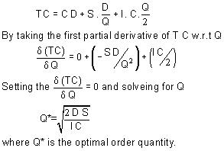

The graphical representation of the EOQ model is shown in Figure 2 .

Figure 2: Economic Order Quantity Model (EOQ Model)

20
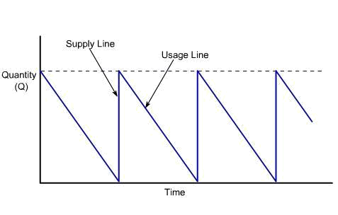

A numeric illustration of the EOQ model is given in example 1.

ABC manufacturers produces 1,25,000 oil seals each year to satisfy the requirement of their client. They order the metal for the bushing in lot of 30,000 units. It cost them $40 to place the order. The unit cost of bushing is $0.12 and the estimated carrying cost is 25% unit cost. Find out the economic order quantity? What percentage of increases or decrease in order quantity is required so that the ordered quantity is Economic order quantity ?
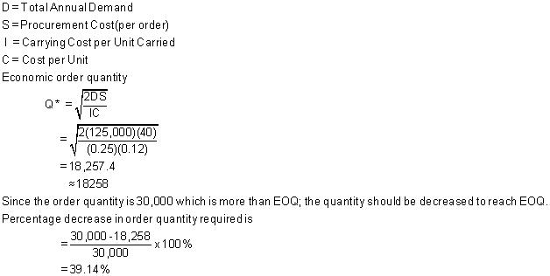

Economic Production Quantity (EPQ) Model

In EOQ model supply was instantaneous, which may not be the case in all industrial applications. If supply of items is gradual to satisfy a continuous demand, then supply line will be depicted by a slanted line (Figure 3 ). Figure 3 : Economic Production Quantity Model (EPQ Model)

21
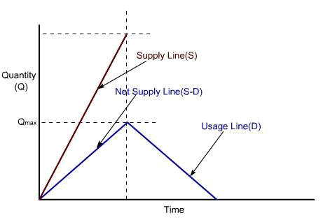

In this situation, when the order is placed, the supplier begins producing the units and supplies them continuously. While new units are added to inventory, other units are being used. Thus, if delivery rate (P) > demand rate (D), the net result will be a net increase in the inventory level. The slope of replenishment line will thus be (P-D). Simillarly the slope of demand line will be (-D). The average inventory carried per year is
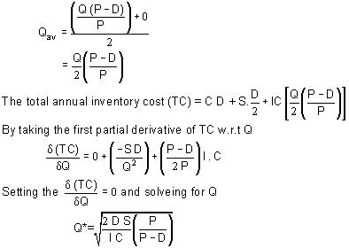

A numeric illstration of the EPQ model is given in

example 2.

The XYZ Company produces wheat flour as one of their product. The wheat flour is produced in the pack of 1kg. The demand for wheat flour is 40,000 packs/year & the production rate is 50,000 packs/year. Wheat flour 1kg pack cost $0.50 each to make. The Procurement cost is $5. The carrying

22
cost is high because the product gets spoiled in few week times span. It is nearly 50 percent of cost of one pack. Find out the operating doctrine.
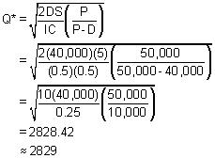

MRP

Introduction

It was discussed in demand forecasting that in the dependent demand situation, if the demand for an item is known, the demand for other related items can be deduced. For example, if the demand of an automobile is known, the demand of its sub assemblies and sub components can easily be deduced.

For dependent demand situations, normal reactive inventory control systems (i.e. EOQ etc.) are not suitable because they result in high inventory costs and unreliable delivery schedules. More recently, managers have realized that inventory planning systems (such as materials requirements planning) are better suited for dependent demand items. MRP is a simple system of calculating arithmetically the requirements of the input materials at different points of time based on actual production plan. MRP can also be defined as a planning and scheduling system to meet time-phased materials requirements for production operations. MRP always tries to meet the delivery schedule of end products as specified in the master production schedule.

MRP Objectives

MRP has several objectives, such as:

- Reduction in Inventory Cost: By providing the right quantity of material at right time to meet master production schedule, MRP tries to avoid the cost of excessive inventory.

23
- Meeting Delivery Schedule: By minimizing the delays in materials procurement, production decision making, MRP helps avoid delays in production thereby meeting delivery schedules more consistently.

- Improved Performance: By stream lining the production operations and minimizing the unplanned interruptions, MRP focuses on having all components available at right place in right quantity at right time.

MRP System

A simple sketch of an MRP system is shown in figure 1. It can be seen from the figure that an MRPsystem has three major input components:

Figure 1: Material Requirements Planning System Architecture
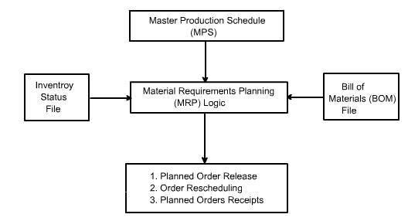

- Master Production Schedule (MPS): MPS is designed to meet the market demand (both the firm orders and forecasted demand) in future in the taken planning horizon. MPS mainly depicts the detailed delivery schedule of the end products. However, orders for replacement components can also be included in it to make it more comprehensive.

- Bill of Materials (BOM) File: BOM represents the product structure. It encompasses information about all sub components needed, their quantity, and their sequence of buildup in the end product. Information about the work centers performing buildup operations is also included in it.

- Inventory Status File: Inventory status file keeps an up-to-date record of each item in the inventory. Information such as, item identification number, quantity on hand, safety stock level, quantity already allocated and the procurement lead time of each item is recorded in this file.

After getting input from these sources, MRP logic processes the available information and gives information about the following:

24
- Planned Orders Receipts: This is the order quantity of an item that is planned to be ordered so that it is received at the beginning of the period under consideration to meet the net requirements of that period. This order has not yet been placed and will be placed in future.

- Planned Order Release: This is the order quantity of an item that is planned to be ordered in the planned time period for this order that will ensure that the item is received when needed. Planned order release is determined by offsetting the planned order receipt by procurement lead time of that item.

- Order Rescheduling: This highlight the need of any expediting, de-expediting, and cancellation of open orders etc. in case of unexpected situations.

CPM

Project Management

A project is a well defined task which has a definable beginning and a definable end and requires one or more resources for the completion of its constituent activities, which are interrelated and which must be accomplished to achieve the objectives of the project. Project management is evolved to coordinate and control all project activities in an efficient and cost effective manner. The salient features of a project are:

- A project has identifiable beginning and end points.

- Each project can be broken down into a number of identifiable activities which will consume time and other resources during their completion.

- A project is scheduled to be completed by a target date.
- A project is usually large and complex and has many interrelated activities.

- The execution of the project activities is always subjected to some uncertainties and risks.

Network Techniques

The network techniques of project management have developed in an evolutionary way in many years. Up to the end of 18th century, the decision making in general and project management in particular was intuitive and depended primarily on managerial capabilities, experience, judgment and academic background of the managers. It was only in the early of 1900's that the pioneers of scientific management, started developing the scientific management techniques. The forerunner to network techniques, the Gantt chart was developed, during world war I, by Henry L Gantt, for the purpose of production scheduling. An example of Gantt chart is shown in Figure 1.

Figure1: Gantt Chart

25
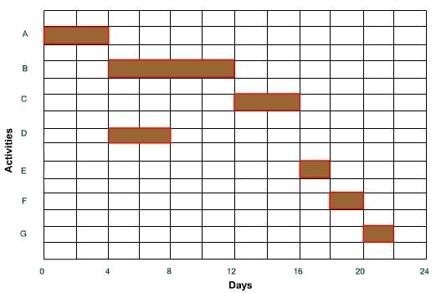

The Gantt chart was later modified to bar chart ( Figure 2 ), Figure 2: Bar Chart
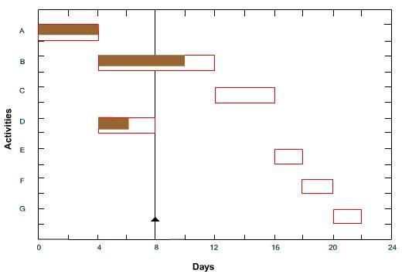

which was used as an important tool in both the project and production scheduling. The bar charts, then developed into milestone charts ( Figure 3 ), and next into network techniques (such as CPM and PERT).

Figure 3: Mile Stone Chart

26
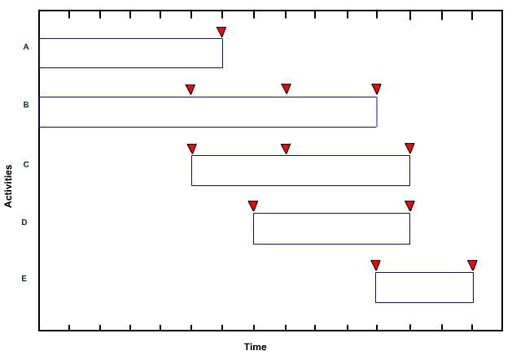

Network Construction

A network is the graphical representation of the project activities arranged in a logical sequence and depicting all the interrelationships among them. A network consists of activities and events.

Activity

An activity is a physically identifiable part of a project, which consumes both time and resources. Activity is represented by an arrow in a network diagram ( Figure 4 ). Figure 4: Activity
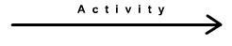

The head of an arrow represents the start of activity and the tail of arrow represents its end. Activity
description and its estimated completion time are written along the arrow. An activity in the network

can be represented by a number of ways: (i) by numbers of its head and tail events (i.e. 10-20 etc.),
and (ii) by a letter code (i.e. A, B etc.). All those activities, which must be completed before the start

of activity under consideration, are called its predecessor activities. All those activities, which have
to follow the activity under consideration, are called its successor activities ( Figure 5 ). Figure 5:

Activity Precedence

27
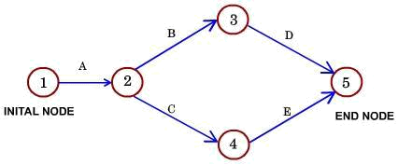

 | Activity |  | Immediate Predecessor
 | A |  | _
 | B |  | A
 | C |  | A
 | D |  | B
 | E |  | C
 | Activity |  | Immediate Successor
 | A |  | B,C
 | B |  | D
 | C |  | E

An activity, which is used to maintain the pre-defined precedence relationship only during the construction of the project network, is called a dummy activity. Dummy activity is represented by a dotted arrow and does not consume any time and resource ( Figure 6 ).

Figure 6: Dummy Activity
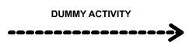

An unbroken chain of activities between any two events is called a path.

Event

An event represents the accomplishment of some task. In a network diagram, beginning and ending of an activity are represented as events. Each event is represented as a node in a network diagram. An event does not consume any time or resource. Each network diagram starts with an initial event and ends at a terminal event. Each node is represented by a circle ( Figure 7) F

igure 7: Event Representation

28


and numbered by using the Fulkerson's Rule. Following steps are involved in the numbering of the nodes:

- The initial event, which has all outgoing arrows and no incoming arrow, is numbered as 1.

- Delete all the arrows coming out from the node just numbered (i.e. 1). This step will create some more nodes (at least one) into initial events. Number these events in ascending order (i.e. 2, 3 etc.).

- Continue the process until the final or terminal node which has all arrows coming in, with no arrow going out, is numbered.

An illustration of Fulkerson's Rule of numbering the events is shown in Figure 8 .

Figure 8: Fulkerson's Rule
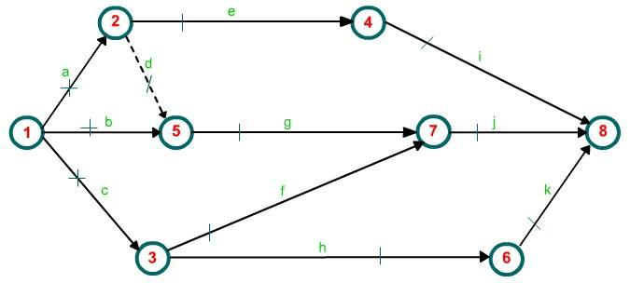

As a recommendation it must be noted that most of the projects are liable for modifications, and hence there should be a scope of adding more events and numbering them without causing any inconsistency in the network. This is achieved by skipping the numbers (i.e. 10, 20, 30…).

Rules for drawing network diagram

Rule 1: Each activity is represented by one and only one arrow in the network.

Rule 2: No two activities can be identified by the same end events ( Figure 9 ).

Figure 9: Network Preparation

29
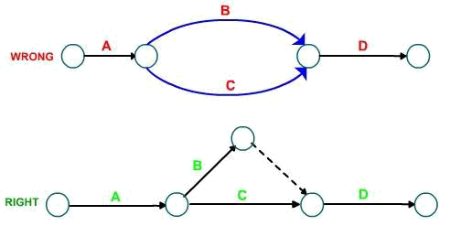

Rule 3: Precedence relationships among all activities must always be maintained.

Rule 4: Dummy activities can be used to maintain precedence relationships only when actually
required. Their use should | be minimized in the network diagram ( Figure 10 ).
 | Figure 10: Use of Dummy Activites
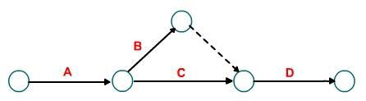

Rule 5: Looping among the activities must be avoided( Figure11 ).

Figure 11: Looping Problem
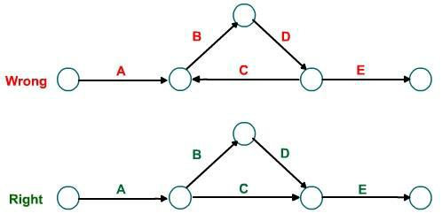

30
CPM and PERT

The CPM (critical path method) system of networking is used, when the activity time estimates are deterministic in nature. For each activity, a single value of time, required for its execution, is estimated. Time estimates can easily be converted into cost data in this technique. CPM is an activity oriented technique.

The PERT (Project Evaluation and Review Technique) technique is used, when activity time estimates are stochastic in nature. For each activity, three values of time (optimistic, most likely, pessimistic) are estimated. Optimistic time (to) estimate is the shortest possible time required for the completion of activity. Most likely time (tm) estimate is the time required for the completion of activity under normal circumstances. Pessimistic time (tp) estimate is the longest possible time required for the completion of activity. In PERT β-distribution is used to represent these three time estimates (Figure 12).

Figure 12: Time distribution curve
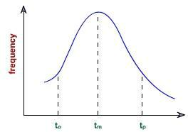

As PERT activities are full of uncertainties, times estimates can not easily be converted in to cost data. PERT is an event oriented technique. In PERT expected time of an activity is determined by using the below given formula:
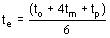

The variance of an activity can be calculated as:
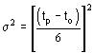

Calculation of Time Estimates in CPM

In the project network given in figure below, activities and their durations are specified at the activities. Find the critical path and the project duration.

31
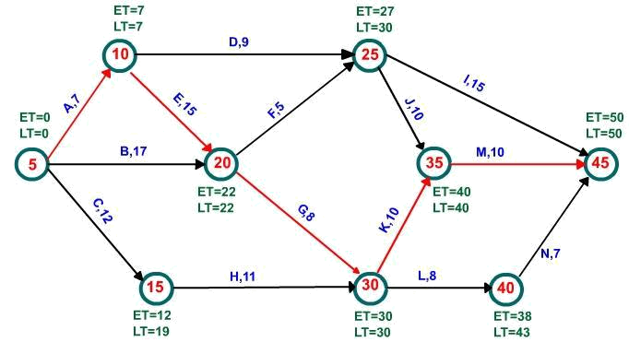

Calculations in Network Analysis

The following calculations are required in network analysis in order to prepare a schedule of the project.

- Total completion time of the project
- Earliest time when each activity can start (i.e. earlist start time)

- Earliest time when each activity can finish (i.e. earlist finished time)

- Latest time when each activity can be started without delaying the project (i.e. latest start time)

- Latest time when each activity can be finished without delaying the project (i.e. latest finish time)

- Float on each activity (i.e. time by which the completion of an activity can be delayed without delaying the project)

- Critical activity and critical path

The symbols used in the calculations are shown in table below.

 | Symbol |  | Description
 | Ei |  | Earliest occurance time of event i
 |  |  | Latest allowable occurance time of event
 | Lj |  | Latest allowable occurance time of event
 | Lj |  | j
 | _{tE}i-j |  | Estimated completion time of activity
 | _{tE}i-j |  | (i,j)
 | (EST)ij |  | Earliest starting time of activity (i,j)

32
(EFT)ij Earliest finishing time of activity (i,j)

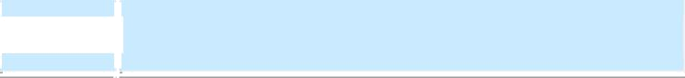
(LST)ij Latest starting time of activity (i,j)

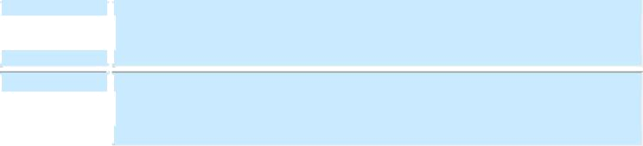

(LFT)ij Latest finishing time of activity (i,j)

The computations are made in following steps.

- Forward Pass Computations :

- Backward Pass Computations :

- Calculation of Slack:
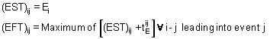
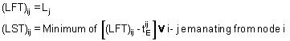

Event slack is defined as the difference between the latest event and earlist event times. Slack for head event = Lj - Ej

Slack for tail event = Li - Ei

The calculations for the above taken example network are summarised below in the table.

 |  |  |  |  |  |  |  |  |  |  |  |  |  |  |  |  | S(i)
 | Predecessor |  | Successor | Event |  |  |  |  |  |  |  |  |  |  |  |  | S(i)
 | Predecessor |  | Successor | Event |  | _{tE}i-j |  | (EST)ij |  | (EFT)ij |  | (LST)ij |  | (LFT)ij
 | Event i |  | j |  |  | _{tE}i-j |  | (EST)ij |  | (EFT)ij |  | (LST)ij |  | (LFT)ij |  |  | Slack
 | 5 |  | 10 |  |  | 7 |  | 0 |  | 7 |  | 0 |  | 7 |  |  | 0
 | 5 |  | 15 |  |  | 12 |  | 0 |  | 12 |  | 7 |  | 19 |  |  | -
 | 5 |  | 20 |  |  | 17 |  | 0 |  | 17 |  | 5 |  | 22 |  |  | -
 | 10 |  | 20 |  |  | 15 |  | 7 |  | 22 |  | 7 |  | 22 |  |  | 0
 | 10 |  | 25 |  |  | 9 |  | 7 |  | 16 |  | 21 |  | 30 |  |  | -
 | 15 |  | 30 |  |  | 11 |  | 12 |  | 23 |  | 19 |  | 30 |  |  | 7
 | 20 |  | 25 |  |  | 5 |  | 22 |  | 27 |  | 25 |  | 30 |  |  | -
 | 20 |  | 30 |  |  | 8 |  | 22 |  | 30 |  | 22 |  | 30 |  |  | 0
 | 25 |  | 35 |  |  | 10 |  | 27 |  | 37 |  | 30 |  | 40 |  |  | 3
 | 25 |  | 45 |  |  | 15 |  | 27 |  | 42 |  | 35 |  | 50 |  |  | -
 | 30 |  | 35 |  |  | 10 |  | 30 |  | 40 |  | 30 |  | 40 |  |  | 0
 |  |  |  |  |  |  |  |  |  |  |  |  |  |  | 33

 |  | 30 |  | 40 |  | 8 |  | 30 |  | 38 |  | 35 |  | 43 |  |  | -
 |  | 35 |  | 45 |  | 10 |  | 40 |  | 50 |  | 40 |  | 50 |  |  | 0
 |  | 40 |  | 45 |  | 7 |  | 38 |  | 45 |  | 43 |  | 50 |  |  | 5

(d) Determination of Critical Path:

The sequance of critical activities in a network is called the critical path. The activities with zero slack of head event and zero slack for tail event, are called as crititcal activities. In the taken network, the following activities are critical activities: 5 - 10, 10 - 20, 20 - 30, 30 - 35, 35 - 45. Thus the critical path is A - E - G - K - M.

Critical path duration is 7 + 15 + 8 + 10 + 10 = 50.

Calculation of Expected Time and Variance of a Path in PERT

The Expected Time of a chain of activities in series, is the sum of their expected times. Similarly the variance of the path, is the sum of variances of activities on the path. In Figure below, three activities A,B and C are connected in series, (i.e. form a path). Their time estimates to-tm-tpare given along the activity arrows. The expected time of the path 1-2-3-4 is calculated as:
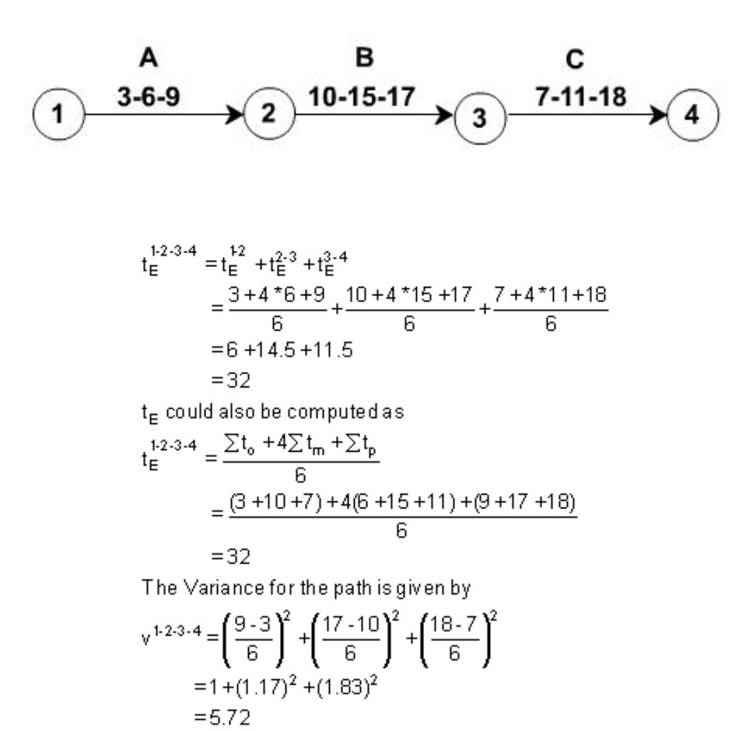

As the length of the path ,that is the number of activies connected in series increases,the variance of the path and hence the uncertainty of meeting the expected time also increases.

34
An Example

In the network of figure below, the PERT time estimates of the activities are written along the activity arrows in the order to-tm-tp. Compute the expected time and variance for each activity. Also compute the expected duration and standard deviation for the following paths of the network.

- 10-20-50-80-90

- 10-30-50-70-90

- 10-40-60-80-90
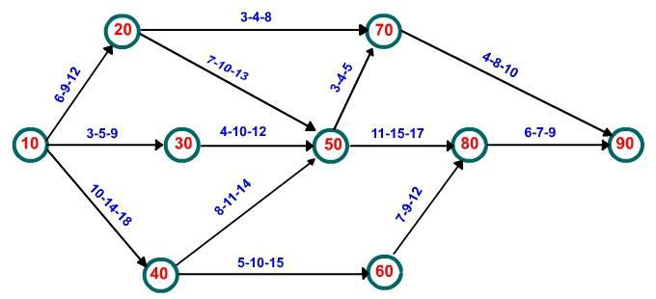

The computation of expected times and variances for different activities are carried in a table given below.

 | Activity |  |  | Time Estimates |  |  |  | Expected Time |  | Variance
 | i | j |  | to | tm | tp |  | tE |  | σ²
 | 10 | 20 |  | 6 | 9 | 12 |  | 9.00 |  | 1.00
 | 10 | 30 |  | 3 | 5 | 9 |  | 5.33 |  | 1.00
 | 10 | 40 |  | 10 | 14 | 18 |  | 14.00 |  | 1.78
 | 20 | 50 |  | 7 | 10 | 13 |  | 10.00 |  | 1.00
 | 20 | 70 |  | 3 | 4 | 8 |  | 4.5 |  | 0.69
 | 30 | 50 |  | 4 | 10 | 12 |  | 9.33 |  | 1.78
 | 40 | 50 |  | 8 | 11 | 14 |  | 11.00 |  | 1.00
 | 40 | 60 |  | 5 | 10 | 15 |  | 10.00 |  | 2.78
 | 50 | 70 |  | 3 | 4 | 5 |  | 4.00 |  | 0.11
 | 50 | 80 |  | 11 | 15 | 17 |  | 14.67 |  | 1.00

35
 | 60 | 80 |  |  | 7 | 9 | 12 |  | 9.17 |  | 0.69
 | 70 | 90 |  |  | 4 | 8 | 10 |  | 7.67 |  | 1.00
 | 80 | 90 |  |  | 6 | 7 | 9 |  | 7.17 |  | 0.25
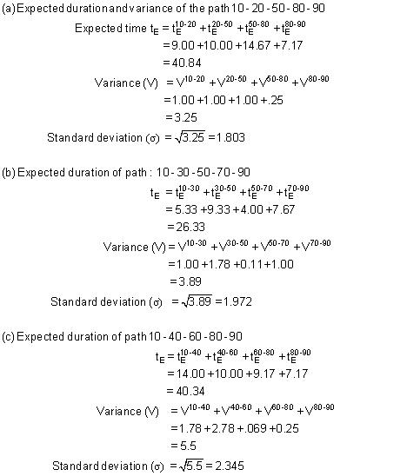

36

