Outlines:
- Introduction
- Types of Electrical Machines
- Types of 3-Ph induction motor
- Basic Principle
- Working Principle
- Compnents of induction motor
- Application
- Comparision between 1-ph I.M. & 3-ph I.M.

 Electrical Machines are Electromechanical energy converson devices.

 Electrical motor coverts electrical energy into mechanical energy and electrcal generators are vice versa.

 Most of the Industrial load are inductive, especially 3-ph induction motors are widely used in industrial applications for continious operation.

1.AC Machines 2.DC Machines
AC Machines:-
- 1-Ph Induction Motor
- 3-Ph Induction Motor
- Synchronous motor
- 1- Ph Transformer
- 3-ph Transformer
- Altrnator or AC Generator

DC Machines:-
-DC Motor
-DC Generator
DC Motor:
- DC Shunt Motor
- DC Series Motor
- DC Compound Wound Motor
DC Generator
- DC Shunt Generator
- DC Series Generator
- DC Compound Wound Generator

Principle of Operation
 A Rotating Magnetic field (RMF) is set up in the stator when a 3- Phase supply is given.
 The stationary rotor cut the revolving field and due to electromagnetic induction an e.m.f. is induced in the rotor conductor.
 As the rotor conductor is short circuited current flows through them.
 It becomes a current carrying conductor in magnetic field and start rotating.

Slip of an Induction Motor

  - Induction motor rotor always rotate at a speed less than
synchronous speed.

  - The difference between the flux (Ns) and the rotor speed (N) is called slip.

  - % Slip (s) = Ns – N
Ns
*100

Where Ns=Synchronous Speed N= Actual Speed of rotor

  - Slip speed = Ns – N

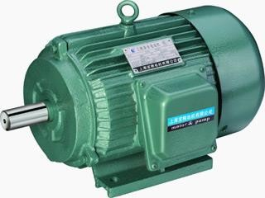

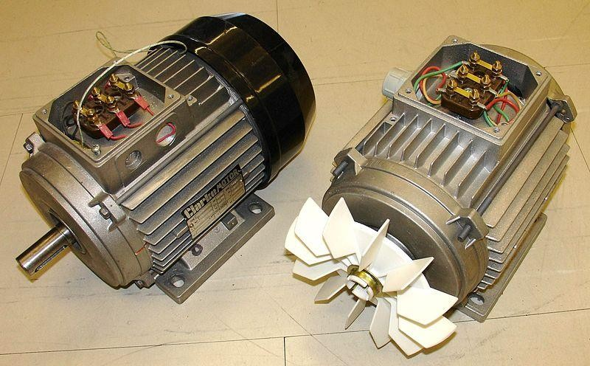

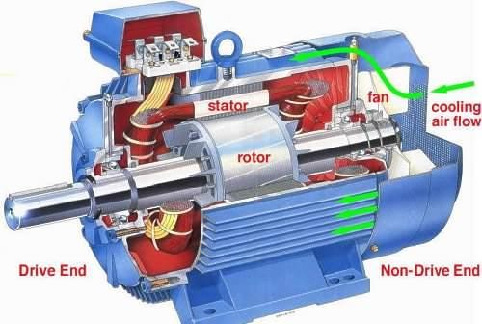

- Frame
- Stator
- Stator Winding
- Rotor
- Rotor Winding
- Cooling Fan
- Bearings Frame:
Frame provides mechanical support to the stator and rotor. It is made from casting materials.
Stator:
It is stationary part of induction motor. It consists stator winding
It is housed on the motor frame.
Arrangement of stator in 3-Ph induction motor are given below:-

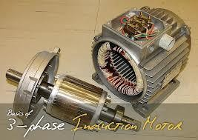Image of Rotor & Stator Winding of 3 phase Induction Motor

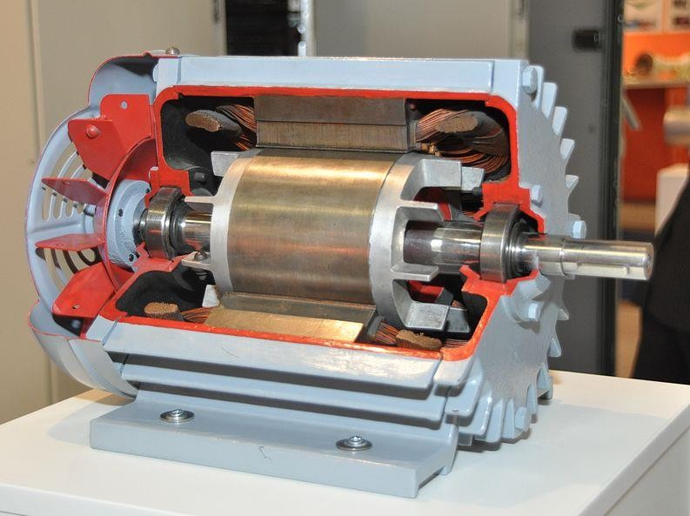

Components of 3-ph Induction Motor

- Rotor:-

- It is the rotating part of the induction motor.
- It is housed on the shaft of the induction motor.
- It has two ends, one is called Driving end and another is called non-
Driving end.
- Mechanical load is connected on driving end while cooling fan is connected on non-driving end.
- Both the ends are connected with bearings for free rotation means of reduced friction losses.
- Arrangement of rotor of induction motor are given below:

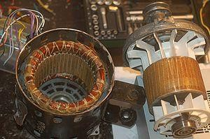

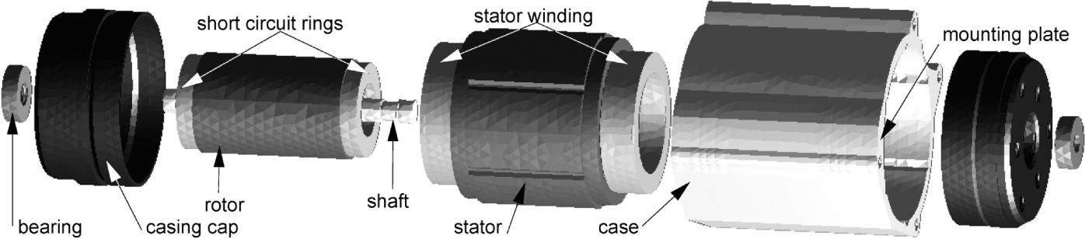

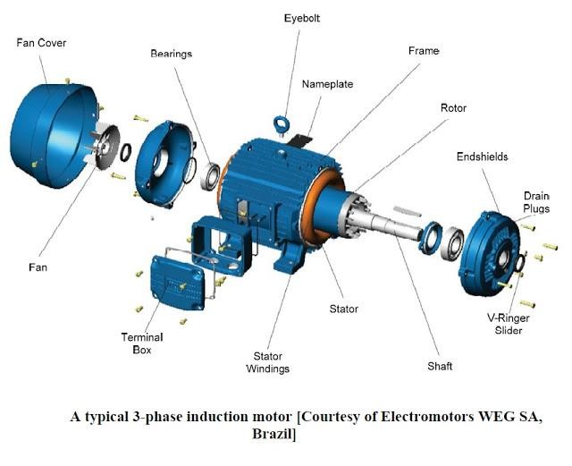

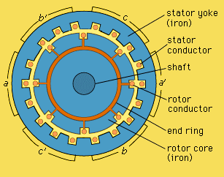

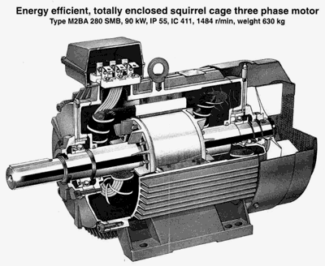

Stator Windings:
 Star connected
 Delta connected

Rotor Windings:
 It is wound as rotor bars and short circuited at both the ends through end rings.

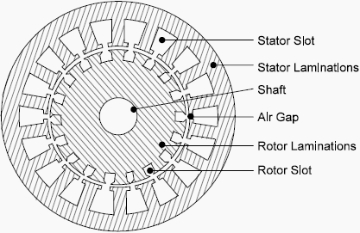

According to rotor construction it can be Classified in two category according to rotor Construction:-

- Squirrel cage induction motor

- Slip ring induction motor

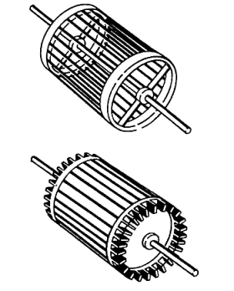

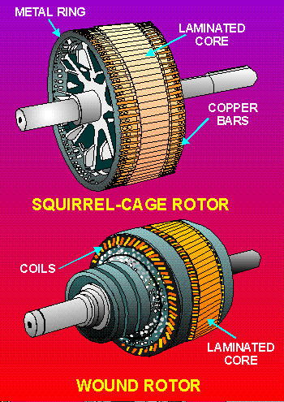

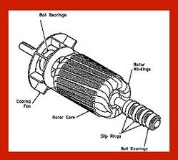

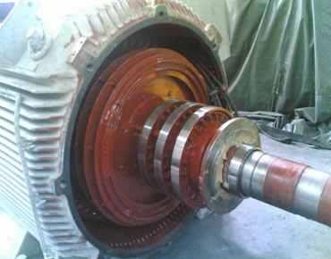

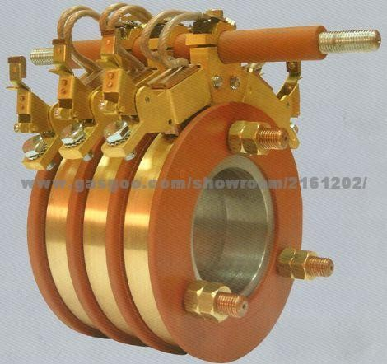

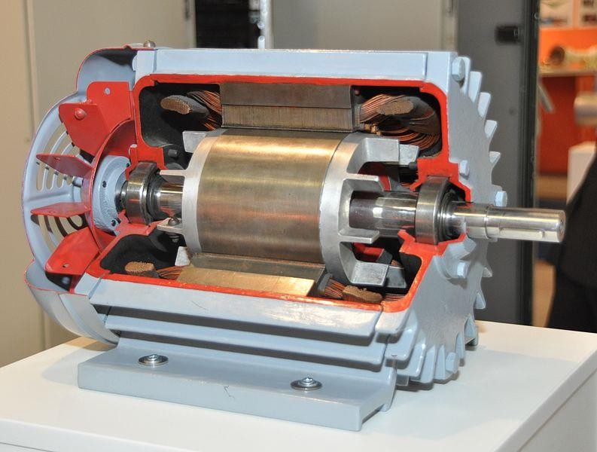

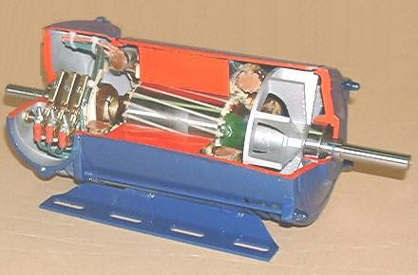

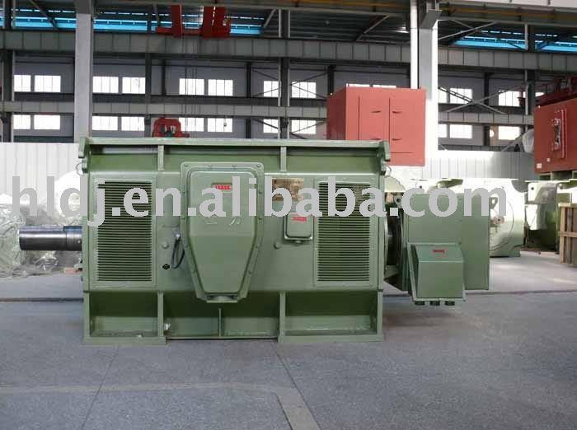

Squirrel cage Induction Motor:-

 Most of the application of industrial as well as domestic are this type of induction motor.
 Its construction is simple and rugged.
 Cheap copare to slipring IM
 Maintainance is easy
 Cost is less compare to slipring IM
 Can use at explosive area
 Starting torque is low compare to slip ring IM
 Application:-
 Leath machine, Compressors,centrifugal pump, in agriculture etc. where cost is most important factor

Slipring Induction Motor:-

- It has high starting torque compare to squirrel cage IM
- Construction is complicated
- Maintanance cost is high compare to squirrel cage IM
- Starter requires compulsory
- Can not use at explosive area
- Application:-
- Crane,hoist,lift and wherehigh starting torque is required

